**Basic Electrical Science Lab  
Course Code: EE152**

**Laboratory Manual**

Name: Sadat Zubin Aftab Shah

Roll No: 20CSE1030

Section: B

Academic Session: April – August 2021

**National Institute of Technology Goa**



**CERTIFICATE**

This is to certify that Mr./ Ms. _____________________ of Class B.Tech 1st year (2nd Sem), Division Sec A/B, bearing Roll. No._____________, has satisfactorily completed the course experiments in the Laboratory Course Basic Electrical Science Lab (EE152) in the academic year 2020-2021 in the Institution of National Institute of Technology Goa.

**Course Instructor**

**Table of Contents**

|  |  |  |  |  |  |
| --- | --- | --- | --- | --- | --- |
| **Sl. No.** | **Name of the Experiment** | **Pg. No.** | **Date of Experiment** | **Date of Submission** | **Marks/Expt.**  **(10 M)** |
| **1** | **Verification of Ohms Law** | **04** | **20-05-2021** | **23-05-2021** |  |
| **2** | **Verification of Kirchhoff's Laws – KVL and KCL** | **11** | **27-05-21** | **31-05-21** |  |
| **3** | **Verification of Thevenin’s and Norton’s Theorem** | **04** | **03-06-21** | **17-06-21** |  |
| **4** | **DC transient analysis of RC RL circuits** | **04** | **24-06-2021** | **02-07-21** |  |
| **5** | **Measurement of Self, Mutual and Coefficient of Coupling** |  |  |  |  |
| **6** | **V-I Characteristics of P-N Junction and Zener Diode** |  |  |  |  |
| **7** | **Half-wave Diode Rectifier** |  |  |  |  |
| **8** | **Full-wave Diode Rectifier** |  |  |  |  |
| **9** | **Transient analysis of RL, RC and RLC Circuits** |  |  |  |  |
| **10** | **Digital Gate Circuits** |  |  |  |  |

**Experiment 4**

**DC transient Analysis**

1. **Introduction:**

This experiment will help us to understand transient analysis of DC circuits through Simulation platform, MATLAB/Simulink.

1. **Objectives:**
2. Acquire a good knowledge on the transient behavior of the DC electrical circuits.
3. Verification of the theoretical knowledge on transient behavior of DC electrical circuits in MATLAB/Simulink Platform.
4. **Simulink Blockset used:** Resistors, voltage source, ramp , AC source, current source, current measurement, voltage measurement, add, divide, display, scope, constant, powergui.
5. **Theory:**

**LR Series Circuit**

A **LR Series Circuit** consists basically of an inductor of inductance, L connected in series with a resistor of resistance, R. The resistance “R” is the DC resistive value of the wire turns or loops that goes into making up the inductors coil. Consider the LR series circuit below.

**The LR Series Circuit**

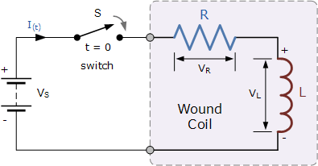

The above *LR series circuit* is connected across a constant voltage source, (the battery) and a switch. Assume that the switch, S is open until it is closed at a time t = 0, and then remains permanently closed producing a “step response” type voltage input. The current, i begins to flow through the circuit but does not rise rapidly to its maximum value of Imax as determined by the ratio of V / R (Ohms Law).

This limiting factor is due to the presence of the self induced emf within the inductor as a result of the growth of magnetic flux, (Lenz’s Law). After a time the voltage source neutralizes the effect of the self induced emf, the current flow becomes constant and the induced current and field are reduced to zero.

Kirchhoff’s voltage law (KVL) gives us:

kirchhoffs voltage law

The voltage drop across the resistor, R is I*R (Ohms Law).

voltage drop across a resistor

The voltage drop across the inductor, L is by now our familiar expression L(di/dt)

voltage drop across an inductor

Then the final expression for the individual voltage drops around the LR series circuit can be given as:

lr series circuit voltage

We can see that the voltage drop across the resistor depends upon the current, i, while the voltage drop across the inductor depends upon the rate of change of the current, di/dt. When the current is equal to zero, ( i = 0 ) at time t = 0 the above expression, which is also a first order differential equation, can be rewritten to give the value of the current at any instant of time as:

**Expression for the Current in an LR Series Circuit**

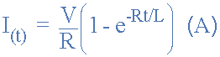

* Where:
* V is in Volts
* R is in Ohms
* L is in Henries
* t is in Seconds
* e is the base of the Natural Logarithm = 2.71828

The **Time Constant**, ( τ ) of the LR series circuit is given as L/R and in which V/R represents the final steady state current value after five time constant values. Once the current reaches this maximum steady state value at 5τ, the inductance of the coil has reduced to zero acting more like a short circuit and effectively removing it from the circuit.

**Transient Curves for an LR Series Circuit**

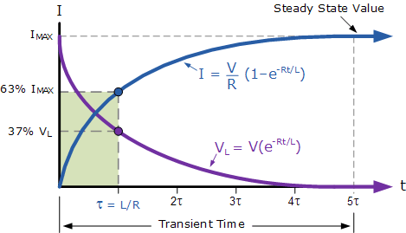

Since the voltage drop across the resistor, VR is equal to I*R (Ohms Law), it will have the same exponential growth and shape as the current. However, the voltage drop across the inductor, VL will have a value equal to:  Ve(-Rt/L). Then the voltage across the inductor, VL will have an initial value equal to the battery voltage at time t = 0 or when the switch is first closed and then decays exponentially to zero as represented in the above curves.

The time required for the current flowing in the LR series circuit to reach its maximum steady state value is equivalent to about **5 time constants** or 5τ. This time constant τ, is measured by τ = L/R, in seconds, where R is the value of the resistor in ohms and L is the value of the inductor in Henries. This then forms the basis of an RL charging circuit were 5τ can also be thought of as “5*(L/R)” or the *transient time* of the circuit

# RC Charging Circuit

When a voltage source is applied to an RC circuit, the capacitor, C charges up through the resistance, R . All Electrical or Electronic circuits or systems suffer from some form of “time-delay” between its input and output terminals when either a signal or voltage, continuous, ( DC ) or alternating ( AC ), is applied to it.  
This delay is generally known as the circuits **time delay** or **Time Constant** which represents the time response of the circuit when an input step voltage or signal is applied. The resultant time constant of any electronic circuit or system will mainly depend upon the reactive components either capacitive or inductive connected to it. Time constant has units of, **Tau –**τ

When an increasing DC voltage is applied to a discharged [**Capacitor**](https://www.electronics-tutorials.ws/capacitor/cap_1.html), the capacitor draws what is called a “charging current” and “charges up”. When this voltage is reduced, the capacitor begins to discharge in the opposite direction. Because capacitors can store electrical energy they act in many ways like small batteries, storing or releasing the energy on their plates as required.This transient response time T, is measured in terms of τ = R x C, in seconds, where R is the value of the resistor in ohms and C is the value of the capacitor in Farads. This then forms the basis of an RC charging circuit were 5T can also be thought of as “5 x RC”.

## RC Charging Circuit

The figure below shows a capacitor, ( C ) in series with a resistor, ( R ) forming a **RC Charging Circuit** connected across a DC battery supply ( Vs ) via a mechanical switch. at time zero, when the switch is first closed, the capacitor gradually charges up through the resistor until the voltage across it reaches the supply voltage of the battery. The manner in which the capacitor charges up is shown below.

### RC Charging Circuit

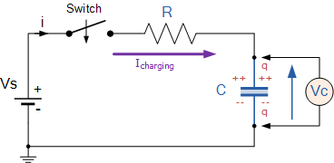

Let us assume above, that the capacitor, C is fully “discharged” and the switch (S) is fully open. These are the initial conditions of the circuit, then t = 0, i = 0 and q = 0. When the switch is closed the time begins at t = 0 and current begins to flow into the capacitor via the resistor.

Since the initial voltage across the capacitor is zero, ( Vc = 0 ) at t = 0 the capacitor appears to be a short circuit to the external circuit and the maximum current flows through the circuit restricted only by the resistor R. Then by using Kirchhoff’s voltage law (KVL), the voltage drops around the circuit are given as:

kirchhoffs voltage law

The current now flowing around the circuit is called the Charging Current and is found by using Ohms law as: i = Vs/R.

### RC Charging Circuit Curves

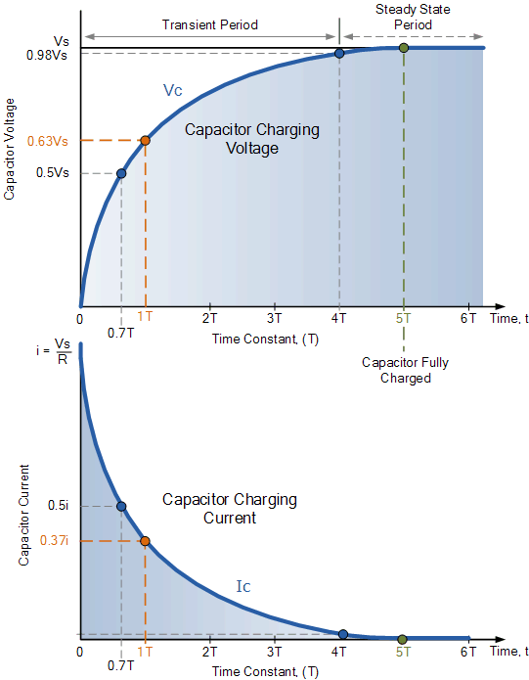

The capacitor (C), charges up at a rate shown by the graph. The rise in the RC charging curve is much steeper at the beginning because the charging rate is fastest at the start of charge but soon tapers off exponentially as the capacitor takes on additional charge at a slower rate.

As the capacitor charges up, the potential difference across its plates begins to increase with the actual time taken for the charge on the capacitor to reach 63% of its maximum possible fully charged voltage, in our curve 0.63Vs, being known as one full Time Constant, ( T ).

This 0.63Vs voltage point is given the abbreviation of 1T, (one time constant).So mathematically we can say that the time required for a capacitor to charge up to one time constant, ( 1T ) is given as:

### RC Time Constant, Tau

rc time constant formula

This RC time constant only specifies a rate of charge where, R is in Ω and C in Farads.

Since voltage V is related to charge on a capacitor given by the equation, Vc = Q/C, the voltage across the capacitor ( Vc ) at any instant in time during the charging period is given as:

capacitor voltage

* Where:
* Vc is the voltage across the capacitor
* Vs is the supply voltage
* e is an irrational number presented by Euler as: 2.7182
* t  is the elapsed time since the application of the supply voltage
* RC is the time constant of the RC charging circuit

After a period equivalent to 4 time constants, ( 4T ) the capacitor in this RC charging circuit is said to be virtually fully charged as the voltage developed across the capacitors plates has now reached 98% of its maximum value, 0.98Vs. The time period taken for the capacitor to reach this 4T point is known as the **Transient Period**.

After a time of 5T the capacitor is now said to be fully charged with the voltage across the capacitor, ( Vc ) being aproximately equal to the supply voltage, ( Vs ). As the capacitor is therefore fully charged, no more charging current flows in the circuit so IC = 0. The time period after this 5T time period is commonly known as the **Steady State Period**.

1. **Statement of Experiments:**

This session consists of two parts. [Vin = 10 V, R = 10 Ω, C = 10 µF, L = 10 mH]

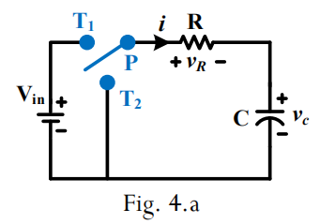

1. Using the circuit diagram shown in Fig. 4.a, characterize the circuit in Matlab/Simulink platform.
2. Replace the capacitor by an inductor in Fig. 4.a, characterize the circuit in Matlab/Simulink platform.
3. **Procedure:**

**a. Part 1.D.a : DC RC circuit**

1. Convert the circuit in Fig. 4.a into experimental circuit.
2. Construct the experimental circuits in MATLAB/Simulink domain, and simulate it in following condition:

* Connect P to T1 at t = 0 sec, and run the simulation for 2 second.
* Connect P to T1 at t = 0 sec, and then connect P to T2 at t = 1 sec. Run the entire simulation for 2 sec.

1. Based on the simulation, fill up the Table - 4.1.
2. Find expression of various responses in the circuit, like current voltage across elements.

**b. Part 1.D.b: DC RL circuit**

Follow the same procedure as mentioned in part 1.E.a, and based on the simulation, prepare an appropriate table and fill up it. Also, find expression of various responses.

1. Observations

* RC circuit
* Simulation 1: Connect P to T1 at t = 0 sec, and run the simulation for 2 second.

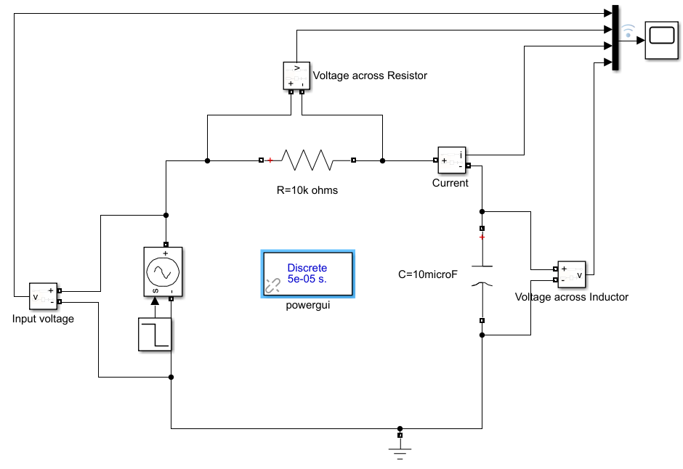

**Fig4a**: Circuit connections for first simulation for RC circuit

Graphical Results:

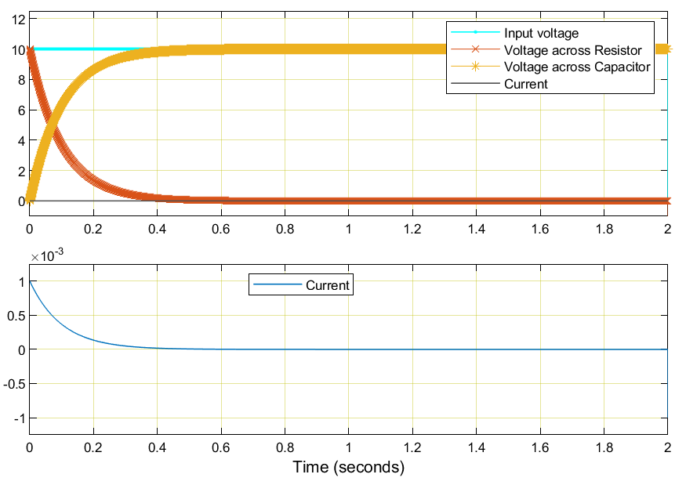

**Graph 4a**: Comparison between various responses in first simulation of RC circuit

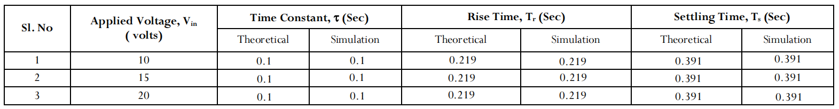

**Obsv table 4a: Tabulation of time constant, rise time and settling time**

Theoretical Calculations:

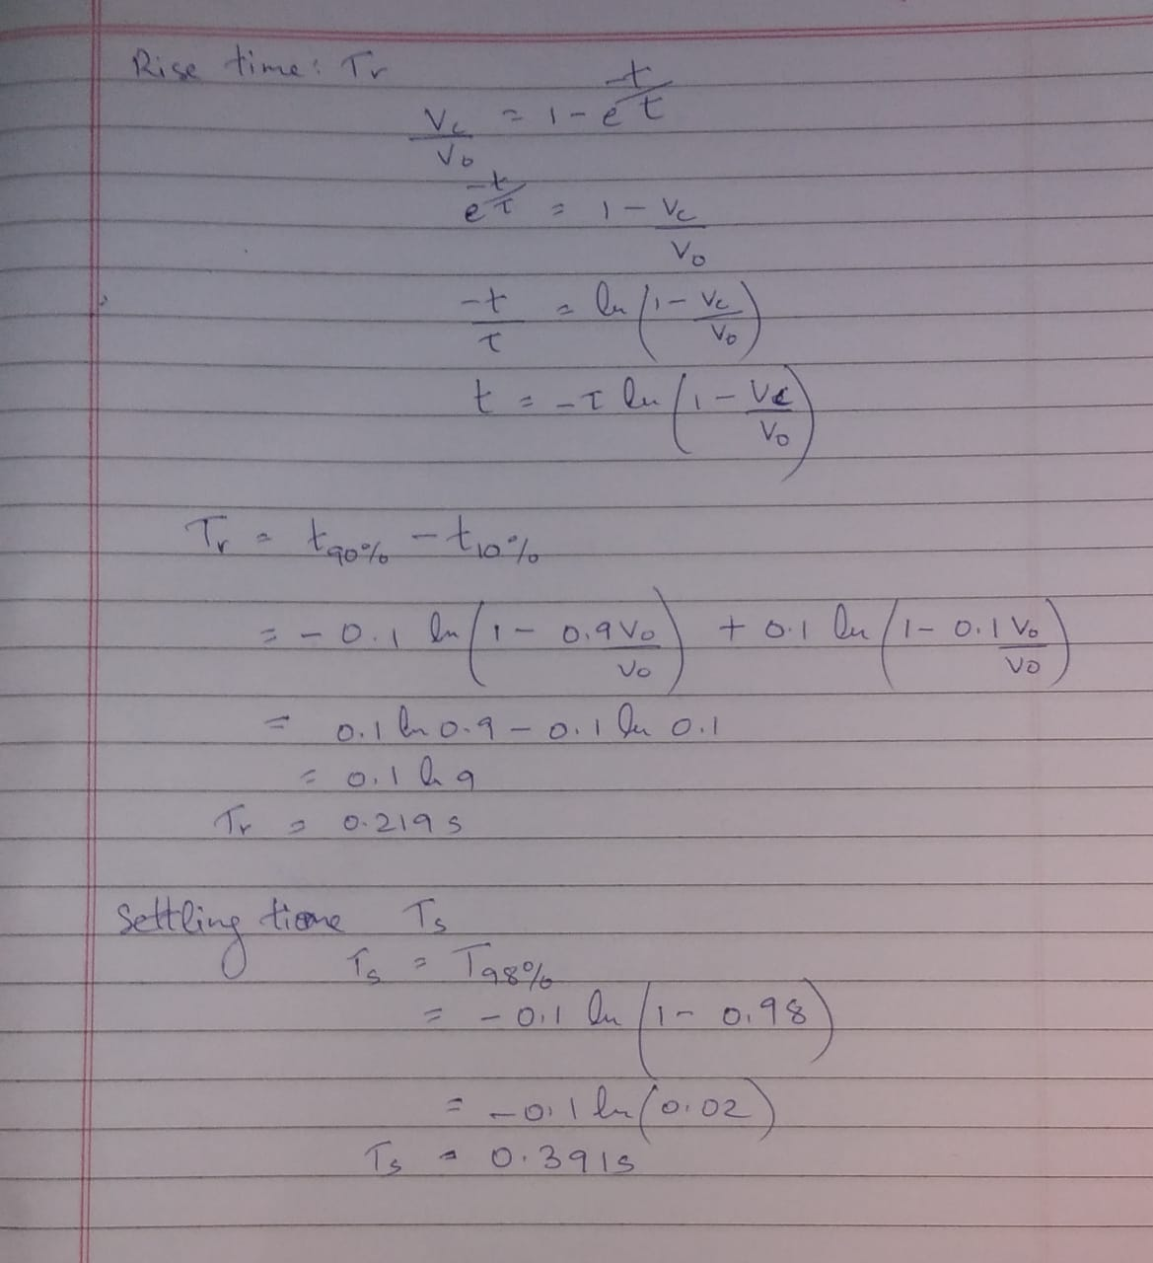

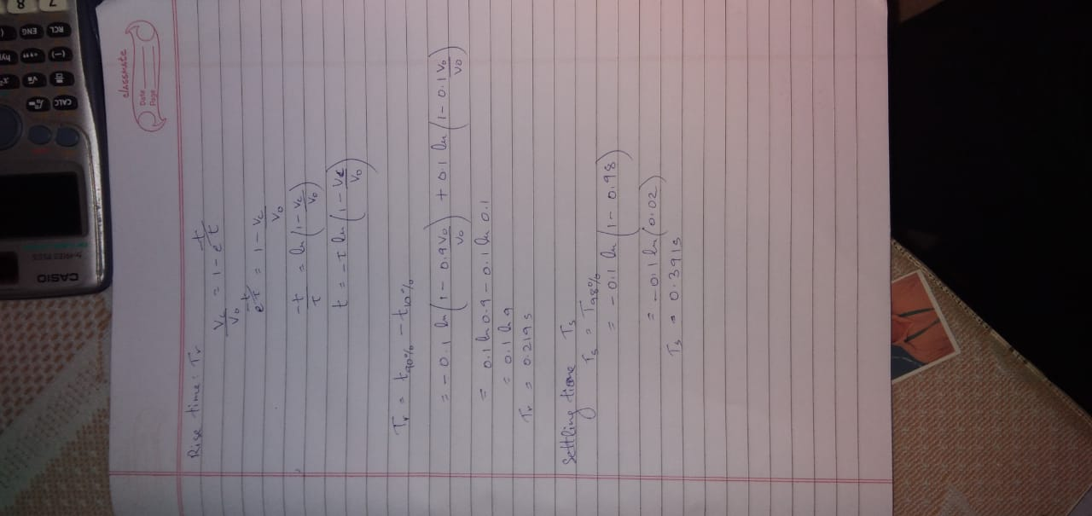

* Simulation 2: Connect P to T1 at t = 0 sec, and then connect P to T2 at t = 1 sec. Run the entire simulation for 2 sec.

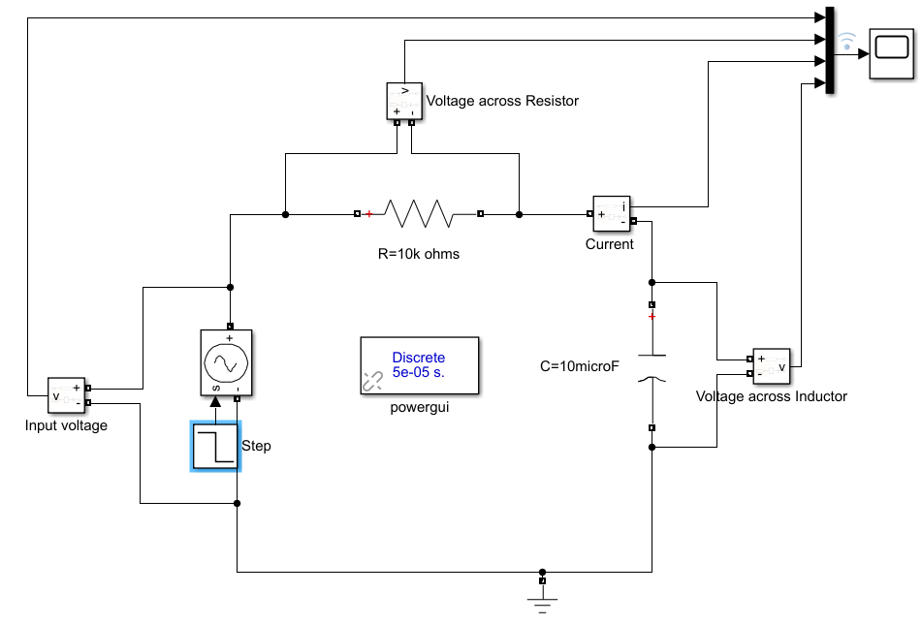

**Fig4b**: Circuit connections for second simulation for RC circuit

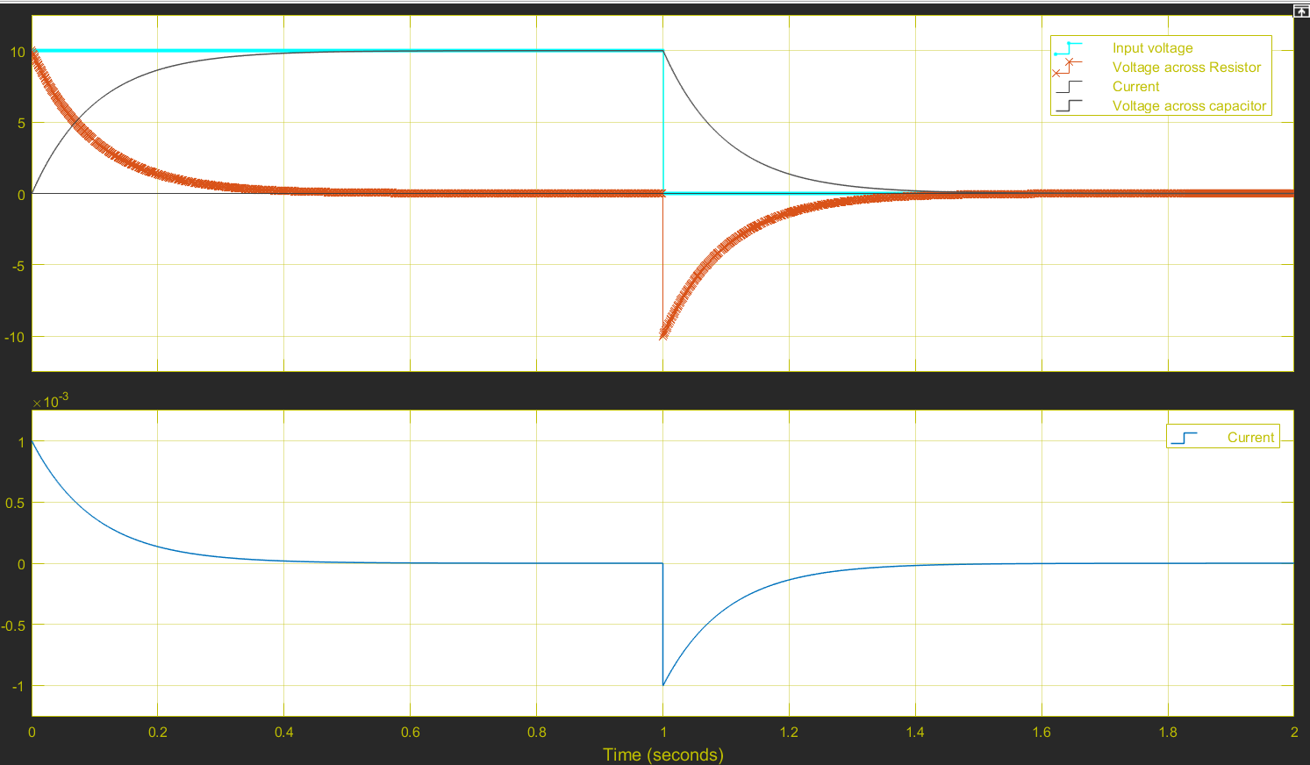

**Graph 4b**: Comparison between various responses in second simulation of RC circuit



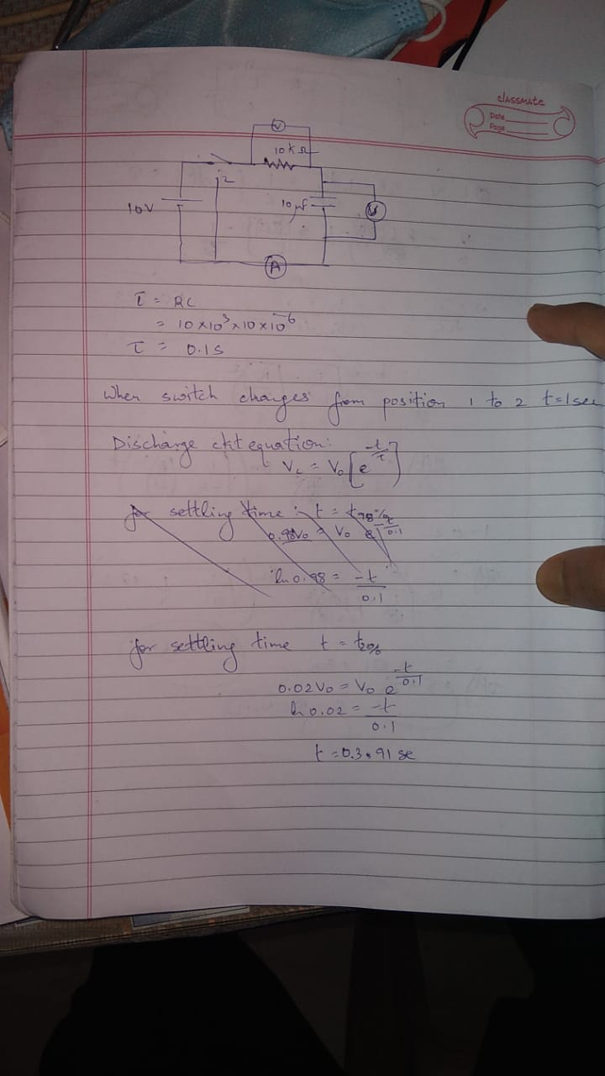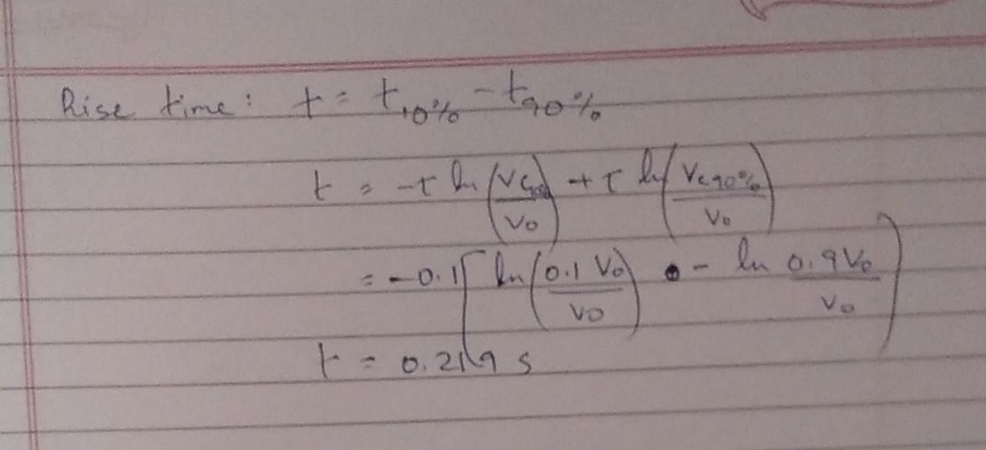

* RL circuit
* Simulation 1: Connect P to T1 at t = 0 sec, and run the simulation for 2 second.

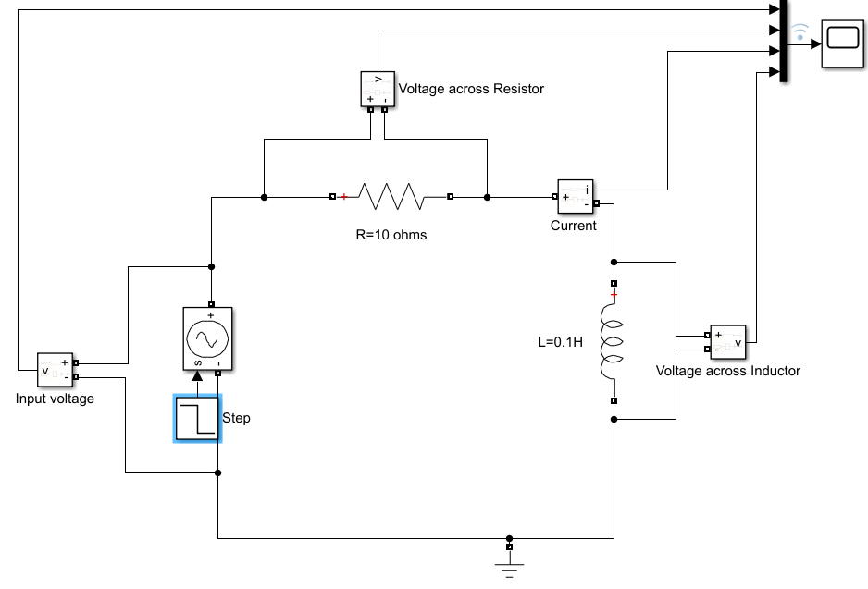

**Fig4c**: Circuit connections for first simulation for RL circuit

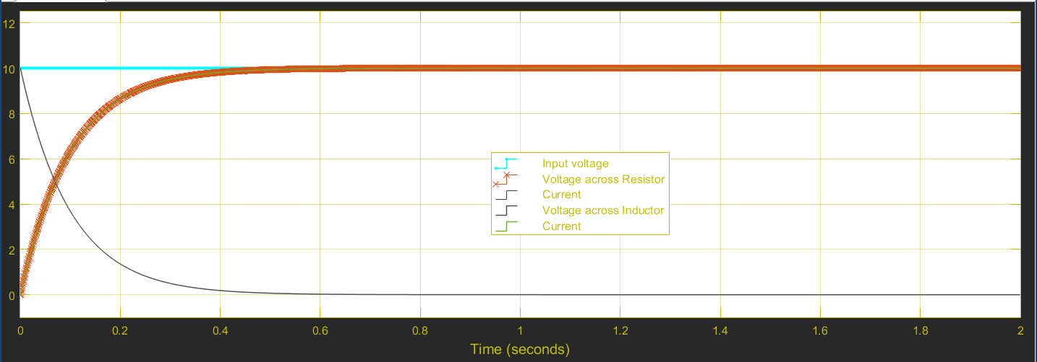

**Graph 4c**: Comparison between various responses in first simulation of RL circuit



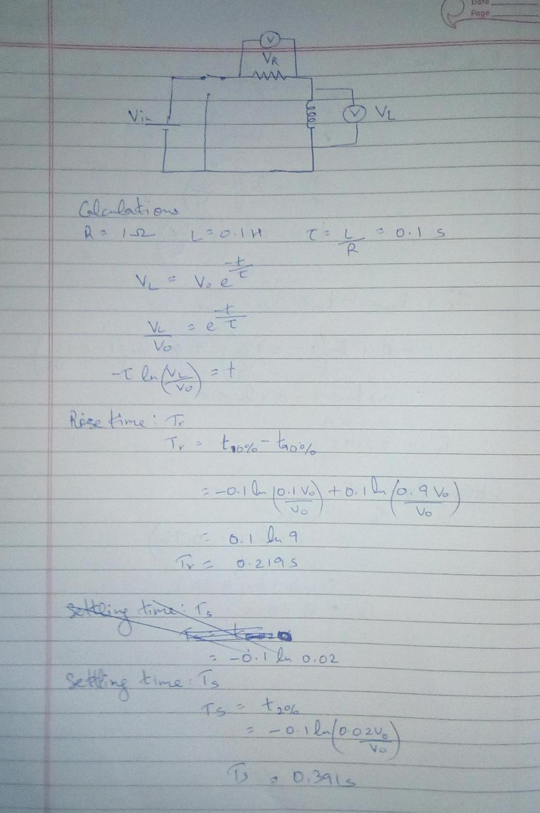



* Simulation 2: Connect P to T1 at t = 0 sec, and then connect P to T2 at t = 1 sec. Run the entire simulation for 2 sec.

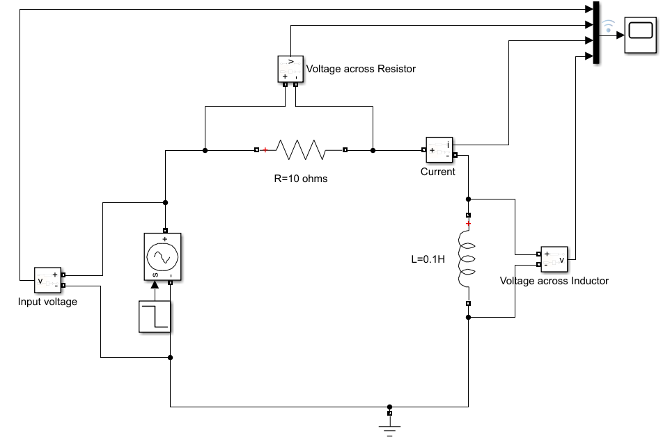

**Fig4d**: Circuit connections for second simulation for RL circuit

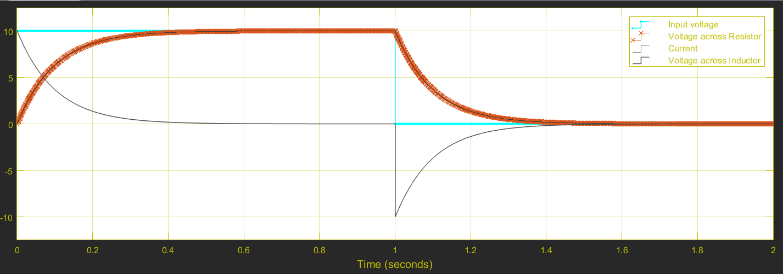

**Graph 4d**: Comparison between various responses in second simulation of RL circuit



1. **Precautions:**
2. Ensure that ‘powergui’ block set is included in the Simulink file
3. Ensure that connections are properly made
4. Ensure that the scale of the graphs should be adjusted to the range in which the readings vary.
5. **Inferences**: From the output graphs and the table values, it can be inferred that the theoretical knowledge of RL DC transient behavior holds true by simulation.
6. **Conclusion:** The RL DC transient analysis simulation verifies the RL DC transient behavior.